Interaction SIP Station II Callout Diagram

This chart outlines callouts shown on the previous page.

|  |  |
| --- | --- |
| 1 | **Mute**. Press this button to disable the headset’s microphone so the other party or parties cannot hear what you are saying. |
| 2 | **Status LED**. Indicates current status of the device. |
| 3 | **Phoneicon Pick Up/Disconnect**. If enabled by your administrator, this button picks up an incoming call or disconnects an active call. |
| 4 | **Volume Down**. When connected to a call, press to adjust caller’s volume down. When not connected to a call, press to adjust ringer volume down. When the minimum volume is reached the LED will blink red once. |
| 5 | **Volume Up**. When connected to a call, adjusts caller’s volume up. When not connected to a call, adjusts ringer volume up. When the maximum volume is reached the LED will blink red once. |
| 6 | **Headset Jack**. Port to connect a standard RJ-9 headset. |
| 7 | **PoE LAN Port**. Port to connect the phone to the Gigabit Ethernet LAN cable for LAN connection. This connection powers the device. |
| 8 | **PC Port**. Port to allow the PC to acquire its Gigabit Ethernet connection through the phone. |

Interaction SIP Station II Device Components

To manage incoming and outgoing calls, the Interaction SIP Station II includes call control buttons and an LED status indicator.

The diagram below highlights the Interaction SIP Station II controls.

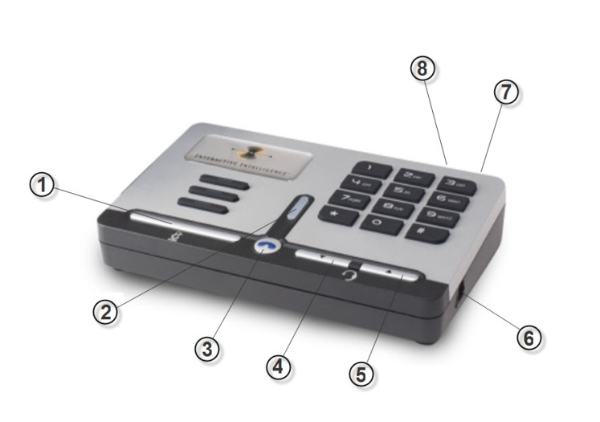

Interaction SIP Station® IIQuick Reference

About Interaction SIP Station II Device

The Interaction SIP Station II is a SIP-based device designed for the   
contact center and enterprise environment, using power over Ethernet, with controls for volume, and mute, on-hook/off-hook. The Interaction SIP Station II phone works with a CIC client and your attached headset to allow you to make or receive calls.

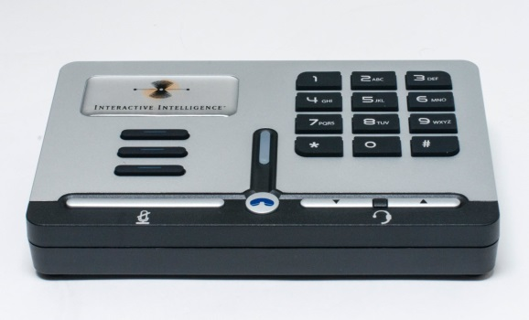

***Interaction SIP Station II***

Increase or Decrease Volume

When connected to a call, press the **Volume Up** or **Volume down**   
buttons to adjust the caller’s volume.

**Note**: When not connected to a call, pressing these buttons will   
adjust the ringer volume.

Pick Up or Disconnect a Call

* To pick up a call, when the call is alerting, press the Phoneicon Phone   
  button on the SIP Station device.
* To disconnect a call, when the call is active, press the Phoneicon Phone   
  button on the SIP Station.

Mute a Caller

There a two ways to mute a call:

* When the call is active, press the **Mute** button. The LED will display as solid red to indicate the call is muted. To remove the call from Mute status, press the Mute button again.
* Or in a CIC client, press the **Mute** button.

**Note**: These methods are not currently linked together. For example, pressing the **Mute** button on the Interaction SIP Station II will not cause the **Mute** button in a CIC client to appear activated. Pressing the **Mute** button in a CIC client will not cause the Interaction SIP Station II LED to display solid red. Either method will successfully mute the call.



Interactive Intelligence

7601 Interactive Way

Indianapolis, IN 46278

Telephone/Fax: (317) 872-3000

[www.inin.com](http://www.inin.com)

|  |  |
| --- | --- |
| DC-012-NVQRC1 | Revised 6/8/2015 |

Interaction SIP Station® II Quick Reference ©1994-2015 Interactive Intelligence, Inc. All rights reserved

LED Device Status

Depending on the status of the Interaction SIP Station II,   
the unit’s LED display changes color.

The following chart lists the LED color and state for common Startup statuses.

|  |  |  |
| --- | --- | --- |
| **Color** | **State** | **Status Description** |
| Orange | Solid | The unit is downloading firmware. |
| Orange | Blinking | The unit is applying firmware. |
| Blue | Blinking | The unit is currently registering. |
| Blue | Solid | The unit is turned on, properly  registered, and ready to receive or make calls. |

The following chart lists the LED color and state for common Active Call statuses.

|  |  |  |
| --- | --- | --- |
| **Color** | **State** | **Status Description** |
| Red | Blinking | A call is alerting and awaiting pickup. |
| Blue | Blinking | The unit is currently connected to a call. |
| Red | Solid | The station audio is muted. |

For a complete explanation of statuses and corresponding LED colors and states, see "LED status light" in the *IC Managed IP Phones Administrator's Guide* in the CIC Documentation Library.